**Implementation of E-Proof for Digital Certificates of Common Recruitment Examination and Basic Law and National Security Law Test**

**Mock-up for the card view of e-Proof document**

**Item 1: Display B/D icon on card view**

* We propose to use the following icon, please refer to the AI and PDF files separately.





**Item 2: Define three labels and attribute information**

* It is suggested that the three labels and attribute information to be displayed as follow –

|  | **Label 1** | **Label 2** | **Label 3** |
| --- | --- | --- | --- |
| **Name of Label (Eng / Chi)** | Candidate /  考生 | Examination Date (DD-MM-YYYY) /  考試日期**（**日-月-年**）** | Types of Examinations / 考試類別 |
| **Data to be retrieved from System** | Name of candidate | Exam date as shown in the 1st paragraph of results notification letter | Display the following   * (English) Common Recruitment Examination and Basic Law and National Security Law Text (Degree / Professional Grades)  (Chinese) 綜合招聘考試及《基本法及香港國安法》測試（學位/專業程度職系） |
| **Example** | CHAN Tai Man | 07-12-2024 | Common Recruitment Examination and Basic Law and National Security Law Text (Degree / Professional Grades) |

[**Note**: As we would only issue result notifications to candidates in English, the attribute information to be displayed for Label 1 and Label 2 will be in English only no matter the card view is using Chinese or English version. See the mock-up below for reference.]

**Item 3: Define issuer**

* The suggested name of issuer is as follow –

|  |  |
| --- | --- |
| Chinese version | 公務員事務局 |
| English version | Civil Service Bureau |

**Mock-up of English and Chinese version of the card view are as follow:**

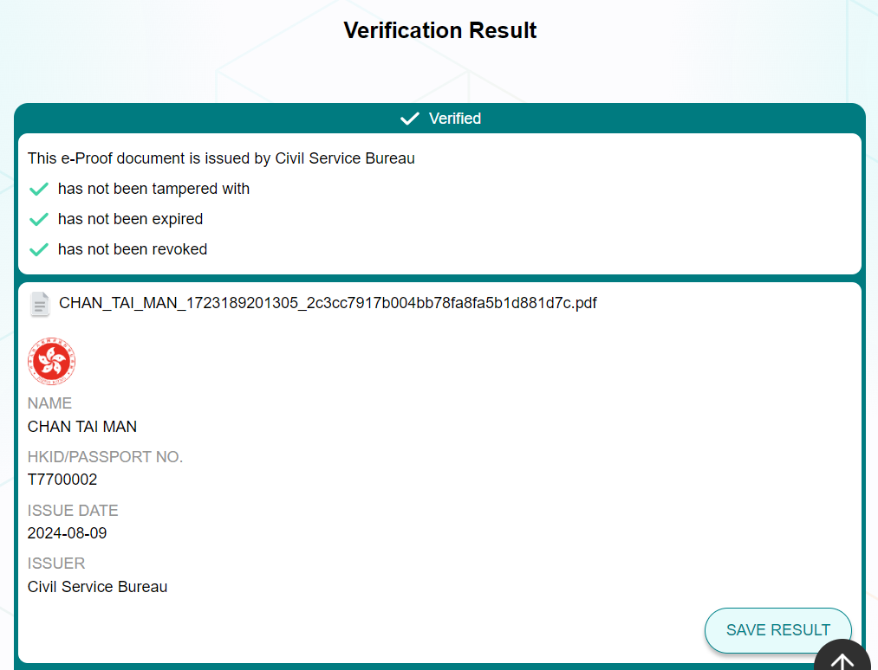

**Candidate**

Chan Tai Man

**Examination Date (DD-MM-YYYY)**

07-12-2024

**Types of Examinations**

Common Recruitment Examination / Basic Law and National Security Law Test (Degree / Professional Grades)

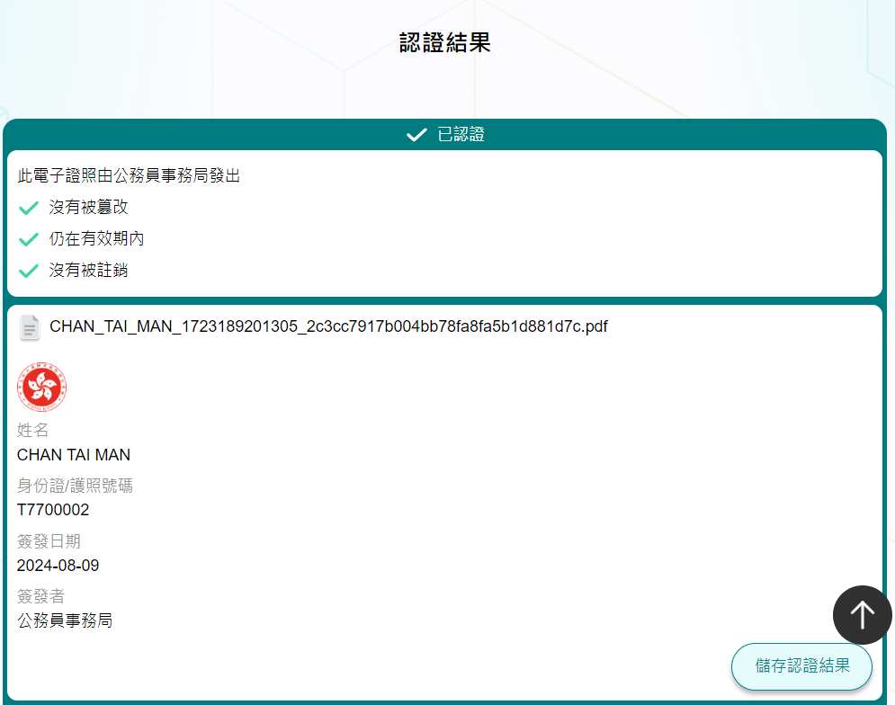

**考生**

Chan Tai Man

**考試日期（日-月-年）**

07-12-2024

考試類別

綜合招聘考試及《基本法及香港國安法》測試（學位/專業程度職系）

Use of English Level 2; Use of Chinese Level 2; Aptitude Test Pass; BLNST Pass

**考試成績**

07-12-2024